Lab 4 ASP.NET

Author: Brian Liang

**Test 1: Technician Service**

Case: Try inputting a valid tech id with open cases.

Results: Returns the open incidents for that technician (one open incident for techID 11)

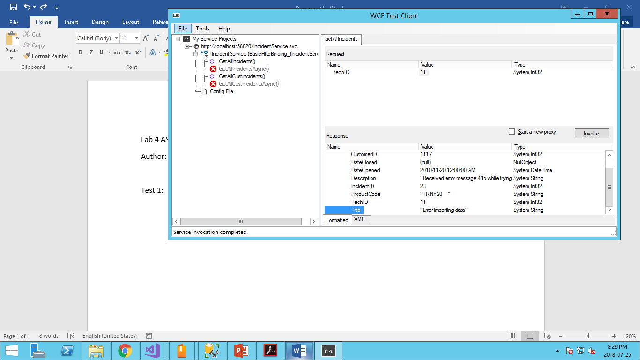

**Test 2: Technician Service**

Case: Try inputting an non existent techID / negative interger

Result: It returned an array of nothing which is correct (we tried techID = -5)

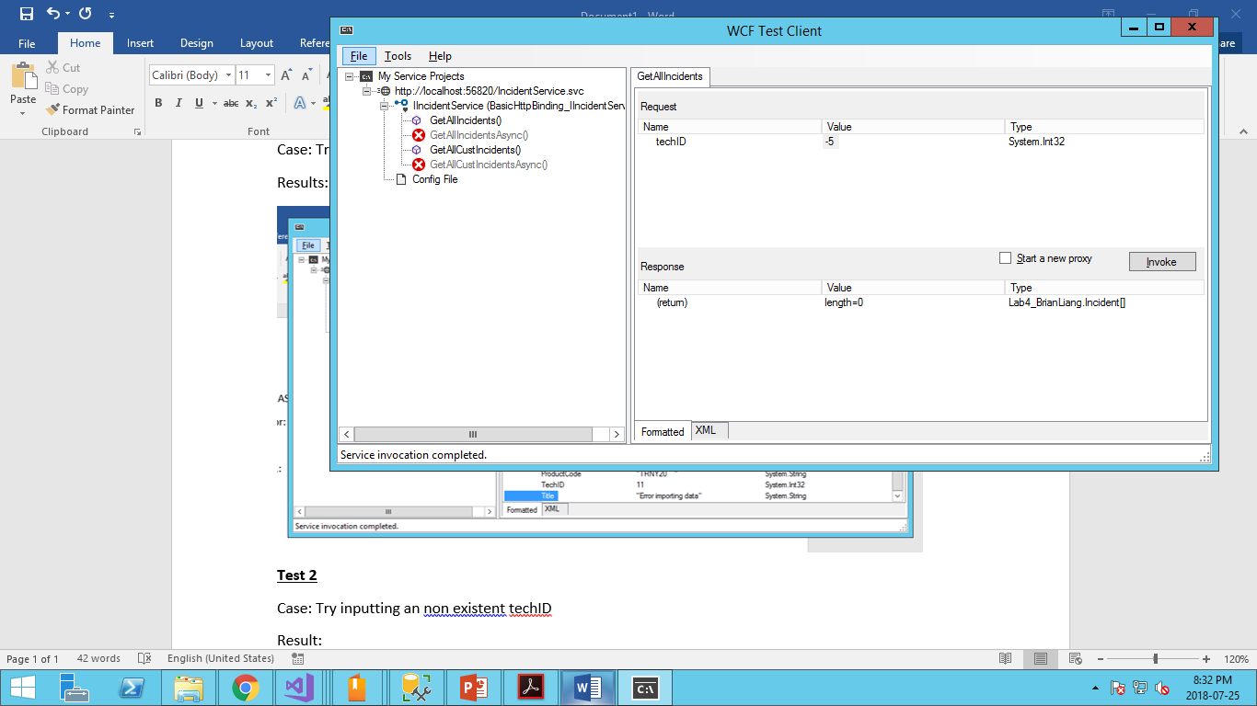

**Test 3: Customer Service**

Test: Test a customer with two incidents

Result: Tested customerID 1116. Initially the program crashed and I learned that it had one item with a techID equal to null (we didn’t need to account for that in lab 3). Therefore I corrected the coding and now am getting the correct answer. The service is returning an array of two and one of them shows TechID as null.

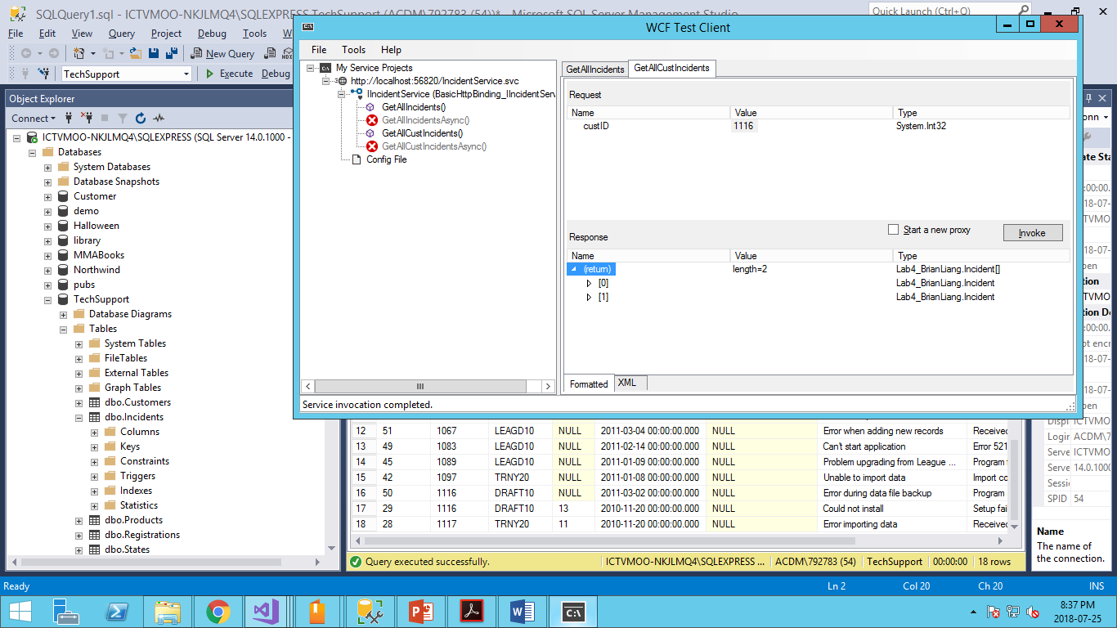 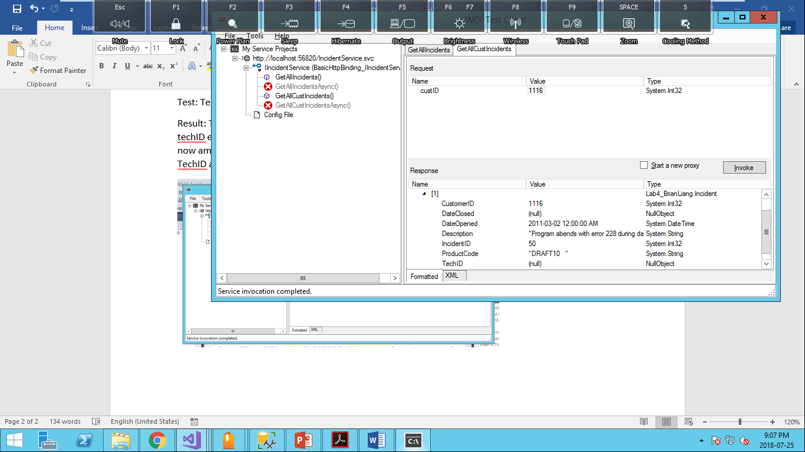

**Test 4: Customer Service**

Test: Test customer ID = 0

Result: Return an array of nothing. Which is correct as there is no customer with ID 0.

